**Result of Explainable AI**

The XGBoost model, trained on 10,000 samples and tested on 4,000, was analyzed using SHAP values at word, sentence, and paragraph levels. Word-wise, SHAP values highlighted key feature contributions, while sentence-wise analysis explained localized patterns and complexity. Paragraph-wise, features like vocabulary size and grammatical mistakes were evaluated, with SHAP values revealing their broader impact, enhancing model interpretability.

**Word wise Result**

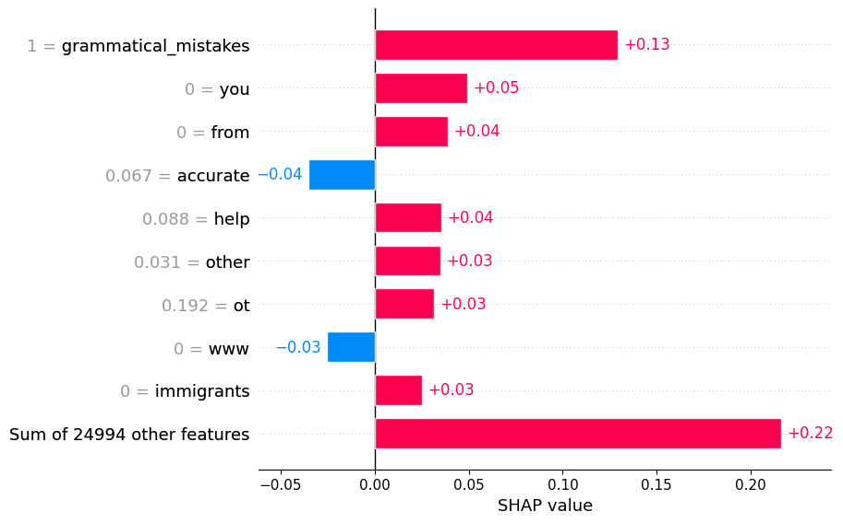

**Sentence wise Result**

**ON MACHINE TEXT**

Predicted Label: 1

Predicted Probability of being AI-generated: 1.0000

Sentence Impact:

Impact: 3.8463 | Sentence: As a vital source of milk, meat, and leather, cows have played a crucial role in sustaining economies and providing nutrition for centuries.

Impact: 3.0073 | Sentence: Their ability to adapt to various environments has made them integral to farming practices worldwide, contributing to food security and rural livelihoods.

Impact: 3.0073 | Sentence: In many cultures, cows hold a sacred status, symbolizing fertility, abundance, and motherhood.

Impact: 3.0061 | Sentence: The cow is a domesticated animal widely known for its significance in agriculture and human society.

Impact: 3.0060 | Sentence: Known for their gentle nature, cows are social animals that form strong bonds within their herds.

Impact: 2.9676 | Sentence: They are ruminants, meaning they have a unique digestive system that allows them to break down tough plant matter, like grass, through a process of fermentation in a specialized stomach.

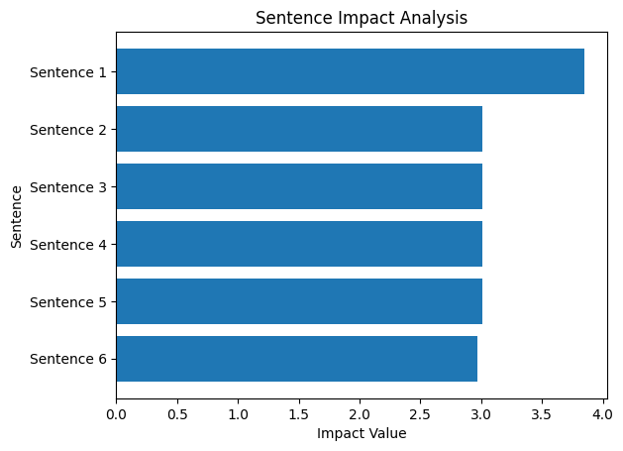

**ON HUMAN TEXT**

Predicted Label: 0

Predicted Probability of being AI-generated: 0.0000

SHAP Explanations:

Sentence Impact Ranking (Most Impactful Sentence First):

Impact: 6.7673 | Sentence: from a particular region or population and was then spread through migration and genetic inter

Impact: 5.9983 | Sentence: the genetics of hair color variation is a complex field of study and there is still much to learn about the factors that influence hair color diversity among.

Impact: 5.8419 | Sentence: different populations one theory is that the gene responsible for hair color variation may have originated.

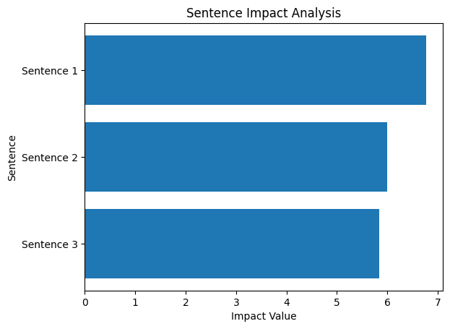

**Shap value: paragraph wise**

**Paragraph used:**

Rent seeking behavior is when people or organizations try to gain financial benefit by using their resources, such as money or influence, to get special privileges or advantages from the government or other organizations, rather than by producing goods or services. It's a way of trying to make money without contributing anything of value to society.

Here are a few examples of rent seeking behavior:

A company lobbies the government to pass a law that gives it a monopoly in a certain market, so it can charge higher prices without competition.

A group of farmers use their political connections to get a subsidy from the government , which pays them money even though they are not producing anything.

An organization uses its influence to get a contract from the government to build a bridge, even though there may be other companies that could do the job more cheaply.

A person uses their connections to get a job or promotion that they are not qualified for.

In general, rent seeking behavior is considered to be harmful to society because it diverts resources away from productive activities and towards unproductive activities, such as lobbying and influence peddling.

